Complex Urban Settlement Indices Implementation on ROI Image (Bahria Town Phase 7)

First we extract a landsat 8 image over Bahria Town Phase-7, Rawalpindi area, using a 2 km buffer and a time range from January 2023 to July 2025. The workflow begins by selecting the clearest Landsat 8 scene in the period, masking out clouds and invalid pixels, and exporting all 11 optical and thermal bands for analysis. It also generates a basic urban mask by combining NDBI and NDVI thresholds to identify built-up areas, which is exported as a separate raster. It incorporates NOAA’s VIIRS Nighttime Lights (NTL) monthly composites to compute both the maximum and 90th percentile brightness values across the time period, exporting both at 30-meter resolution to align with Landsat. For vegetation monitoring, the code calculates the Normalized Difference Vegetation Index (NDVI) for every Landsat scene, then computes and exports their pixelwise maximum values as separate layers. Additionally to calculate maximum LST (Land Surface Temperature) for Landsat 8, we also export annual maximum for these dates so that we could get annual maximum of all the bands. Finally, the script provides quick visual previews of the results and exports all processed images—including the Landsat stack, Landsat annual stack vegetation indice, urban mask, and NTL layers—to Google Drive for further analysis in Python or GIS. In short, this script automates the preparation of key urban and vegetation indicators for your study area, ready for advanced index computation and urban analysis. Dynamic World Labels classes were used as classes for the mask. Dynamic World Labels has class names:
- Water
- Trees
- Grass
- Flooded Vegetation
- Crops
- Shrub & Scrub
- Built
- Bare
- Snow & Ice
The code used for extraction was:
/********************* USER SETTINGS **************************/
var BUFFER_METERS = 2000; // ~2 km radius
var DATE_START = '2023-01-01';
var DATE_END = '2025-07-01';
var CLOUD_THRESH = 10; // % cloud cover (scene-wide)
var DRIVE_FOLDER = 'GEE_Exports'; // change if you like
/****************************************************************/

// 1. Build filtered collection (as you already do)
var col = ee.ImageCollection('LANDSAT/LC08/C02/T1_TOA')
.filterBounds(roi)
.filterDate(DATE_START, DATE_END)
.filter(ee.Filter.lt('CLOUD_COVER', CLOUD_THRESH));

// 2. Mask clouds for each image in the collection
function maskClouds(img) {
var qa = img.select('QA_PIXEL');
var good = qa.bitwiseAnd(1 << 0).eq(0)
.and(qa.bitwiseAnd(1 << 1).eq(0))
.and(qa.bitwiseAnd(1 << 2).eq(0))
.and(qa.bitwiseAnd(1 << 3).eq(0));
return img.updateMask(good);
}
var col_masked = col.map(maskClouds);

// 3. Select the 11 bands
var bands = ['B1','B2','B3','B4','B5','B6','B7','B8','B9','B10','B11'];

// 4. Get pixelwise max for each band across all images in the collection
var maxBands = col_masked.select(bands).max().clip(roi);

// 5. Export the annual max composite
Export.image.toDrive({
image: maxBands,
description: 'L8_BahriaPhase7_AnnualMax11Bands',
folder: DRIVE_FOLDER,
fileNamePrefix: 'L8_BahriaPhase7_AnnualMax11Bands_' + DATE_START.replace(/-/g,'') + '_' + DATE_END.replace(/-/g,''),
region: roi,
scale: 30,
crs: 'EPSG:4326',
maxPixels: 1e10
});

// 6. QUICK URBAN MASK (NDBI>0 & NDVI<0.2)
var ndvi = l8.normalizedDifference(['B5','B4']).rename('NDVI');
var ndbi = l8.normalizedDifference(['B6','B5']).rename('NDBI');
var urbanMask = ndbi.gt(0).and(ndvi.lt(0.2))
.rename('urban_mask');

// 7. VIIRS Nighttime Lights extraction (median composite for time range)
var viirs_col = ee.ImageCollection("NOAA/VIIRS/DNB/MONTHLY_V1/VCMCFG")
.filterBounds(roi)
.filterDate(DATE_START, DATE_END)
.select('avg_rad');

// 2. Create a per-pixel max composite (annual max)
var viirs_ntl_max = viirs_col.max().clip(roi);

// 3. Optionally, 90th percentile instead of strict max:
var viirs_ntl_p90 = viirs_col.reduce(ee.Reducer.percentile([90])).select('avg_rad_p90').clip(roi);

// 4. Export as before
Export.image.toDrive({
image: viirs_ntl_max,
description: 'VIIRS_NTL_MAX_BahriaPhase7',
folder: DRIVE_FOLDER,
fileNamePrefix: 'VIIRS_NTL_MAX_BahriaPhase7_' + DATE_START.replace(/-/g,'') + '_' + DATE_END.replace(/-/g,''),
region: roi,
scale: 30,
crs: 'EPSG:4326',
maxPixels: 1e10
});

Export.image.toDrive({
image: viirs_ntl_p90,
description: 'VIIRS_NTL_90p_BahriaPhase7',
folder: DRIVE_FOLDER,
fileNamePrefix: 'VIIRS_NTL_90p_BahriaPhase7_' + DATE_START.replace(/-/g,'') + '_' + DATE_END.replace(/-/g,''),
region: roi,
scale: 30,
crs: 'EPSG:4326',
maxPixels: 1e10
});

// 8. VISUAL PREVIEW
Map.centerObject(roi, 14);
Map.addLayer(allBands, {bands:['B4','B3','B2'], min:0.05, max:0.4}, 'L8 RGB');
Map.addLayer(urbanMask.updateMask(urbanMask), {palette:['black','red']}, 'Urban mask');
Map.addLayer(viirs_ntl_max, {min:0, max:50, palette:['black','blue','cyan','yellow','white']}, 'NTL (VIIRS)');
Map.addLayer(viirs_ntl_p90,{min:0, max:50, palette:['yellow']}, 'NTL (90 percent)');

// 9. EXPORT — 11-band image (Landsat)
Export.image.toDrive({
image: allBands,
description: 'L8_BahriaPhase7_11Bands',
folder: DRIVE_FOLDER,
fileNamePrefix: 'L8_BahriaPhase7_' + l8.date().format('yyyyMMdd').getInfo(),
region: roi,
scale: 30,
crs: 'EPSG:4326',
maxPixels: 1e10
});

// 10. EXPORT — binary urban mask (Landsat-based)
Export.image.toDrive({
image: urbanMask,
description: 'UrbanMask_BahriaPhase7',
folder: DRIVE_FOLDER,
fileNamePrefix: 'UrbanMask_BahriaPhase7_' + l8.date().format('yyyyMMdd').getInfo(),
region: roi,
scale: 30,
crs: 'EPSG:4326',
maxPixels: 1e10
});

// ******************************
// USER SETTINGS
// ******************************
var BUFFER_METERS = 2000; // ~2 km radius
var DATE_START = '2023-01-01';
var DATE_END = '2025-07-01';
var CLOUD_THRESH = 10; // % cloud cover
var DRIVE_FOLDER = 'GEE_Exports';
// ROI: Bahria Town Phase-7, Rawalpindi
var roi = ee.Geometry.Point(73.11988, 33.53081).buffer(BUFFER_METERS);

// ******************************
// IMAGE COLLECTION
// ******************************
var col = ee.ImageCollection('LANDSAT/LC08/C02/T1_TOA')
.filterBounds(roi)
.filterDate(DATE_START, DATE_END)
.filter(ee.Filter.lt('CLOUD_COVER', CLOUD_THRESH));

// ******************************
// NDVI CALCULATION
// ******************************
var addNDVI = function(img) {
var ndvi = img.normalizedDifference(['B5', 'B4']).rename('NDVI');
return img.addBands(ndvi);
};
var col_ndvi = col.map(addNDVI);

// ******************************
// MAX COMPOSITES
// ******************************
var ndvi_max = col_ndvi.select('NDVI').max().clip(roi);

// ******************************
// EXPORT TO DRIVE
// ******************************

Export.image.toDrive({
image: ndvi_max,
description: 'L8_NDVImax_BahriaPhase7',
folder: DRIVE_FOLDER,
fileNamePrefix: 'L8_NDVImax_BahriaPhase7_' + DATE_START.replace(/-/g,'') + '_' + DATE_END.replace(/-/g,''),
region: roi,
scale: 30,
crs: 'EPSG:4326',
maxPixels: 1e10
});

After downloading the images and masks. I viewed the images and masks:
import rasterio
import numpy as np
import matplotlib.pyplot as plt
from skimage.transform import resize
from matplotlib.colors import ListedColormap
import os
# ========== FILE PATHS ==========
landsat_path = r'C:\Users\Adeel Ajmal\Downloads\L8_BahriaPhase7_20231012.tif'
landsat_annual_path = r'C:\Users\Adeel Ajmal\Downloads\L8_BahriaPhase7_AnnualMax11Bands_20230101_20250701.tif'
label_path = r'C:\Users\Adeel Ajmal\Downloads\DynamicWorld_LandcoverLabels.tif'
viirs_path = r'C:\Users\Adeel Ajmal\Downloads\VIIRS_NTL_90p_BahriaPhase7_20230101_20250701.tif'
ndvi_max_path = r'C:\Users\Adeel Ajmal\Downloads\L8_NDVImax_BahriaPhase7_20230101_20250701.tif'

outdir = "urban_index_eval_complex_all"
os.makedirs(outdir, exist_ok=True)

# ========== 1. Landsat True Color ==========
with rasterio.open(landsat_path) as src:
rgb = src.read([4,3,2]) # Bands 4,3,2 = RGB
rgb = np.moveaxis(rgb, 0, -1)

def stretch(img):
img = img.astype('float32')
p2, p98 = np.nanpercentile(img, (2, 98))
return np.clip((img - p2) / (p98 - p2), 0, 1)

plt.figure(figsize=(7,6))
plt.imshow(stretch(rgb))
plt.title('Landsat-8 RGB (True Color)')
plt.axis('off')
plt.savefig(os.path.join(outdir, "landsat8_rgb.png"), bbox_inches='tight', dpi=200)
plt.show()

# ========== 2. Landsat Annual Max (visualize Band 4 as example) ==========
with rasterio.open(landsat_annual_path) as src:
band4 = src.read(11) # Band 4 (Red) as an example
plt.figure(figsize=(7,6))
plt.imshow(band4, cmap='magma')
plt.title('Landsat-8 Annual Max (Band 11)')
plt.colorbar()
plt.axis('off')
plt.savefig(os.path.join(outdir, "landsat8_annualmax_band10.png"), bbox_inches='tight', dpi=200)
plt.show()

# ========== 3. Dynamic World Landcover Labels ==========
with rasterio.open(label_path) as src:
labels = src.read(1)
if labels.shape != rgb.shape[:2]:
labels_resized = resize(labels, rgb.shape[:2], order=0, preserve_range=True, anti_aliasing=False).astype(int)
else:
labels_resized = labels
class_palette = [
"#419bdf", "#397d49", "#88b053", "#7a87c6", "#e49635",
"#dfc35a", "#c4281b", "#a59b8f", "#ffffff"
]
plt.figure(figsize=(7,6))
plt.imshow(stretch(rgb))
plt.imshow(labels_resized, cmap=ListedColormap(class_palette), alpha=0.35, vmin=0, vmax=8)
plt.title('Landsat RGB + Dynamic World Labels')
plt.axis('off')
plt.savefig(os.path.join(outdir, "landsat_rgb_dw_labels.png"), bbox_inches='tight', dpi=200)
plt.show()

# ========== 4. VIIRS Nighttime Lights ==========
with rasterio.open(viirs_path) as src:
viirs = src.read(1)
plt.figure(figsize=(7,6))
plt.imshow(viirs, cmap='plasma')
plt.title('VIIRS Nighttime Lights (90th Percentile)')
plt.colorbar()
plt.axis('off')
plt.savefig(os.path.join(outdir, "viirs_ntl_90p.png"), bbox_inches='tight', dpi=200)
plt.show()

# ========== 5. NDVI Max ==========
with rasterio.open(ndvi_max_path) as src:
ndvi = src.read(1)
plt.figure(figsize=(7,6))
plt.imshow(ndvi, cmap='YlGn')
plt.title('NDVI Max (Landsat 8)')
plt.colorbar()
plt.axis('off')
plt.savefig(os.path.join(outdir, "ndvi_max.png"), bbox_inches='tight', dpi=200)
plt.show()

print("Done visualizing selected files!")

Output:
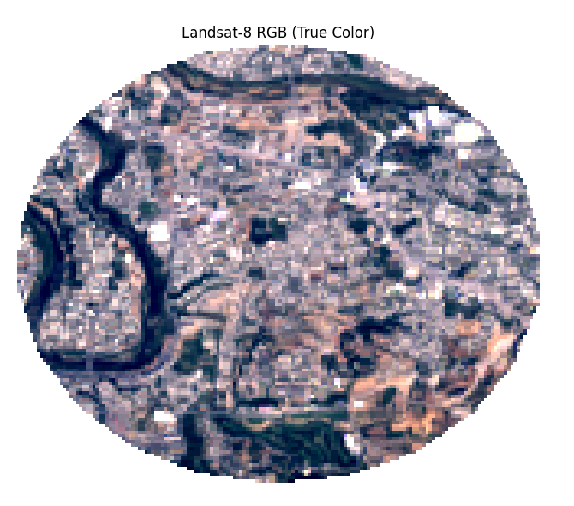
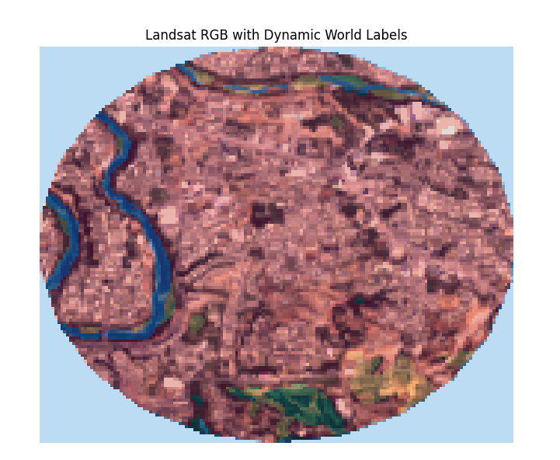
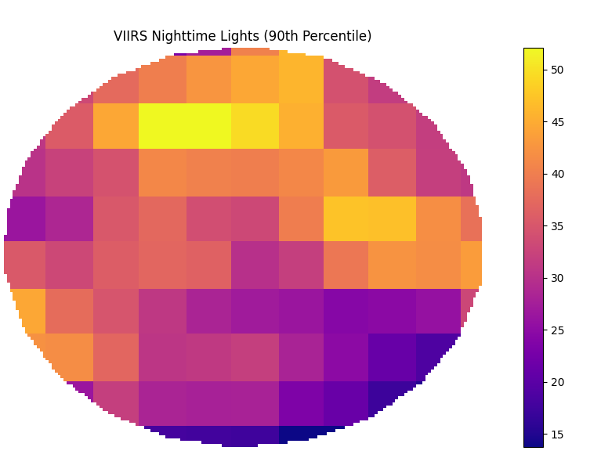

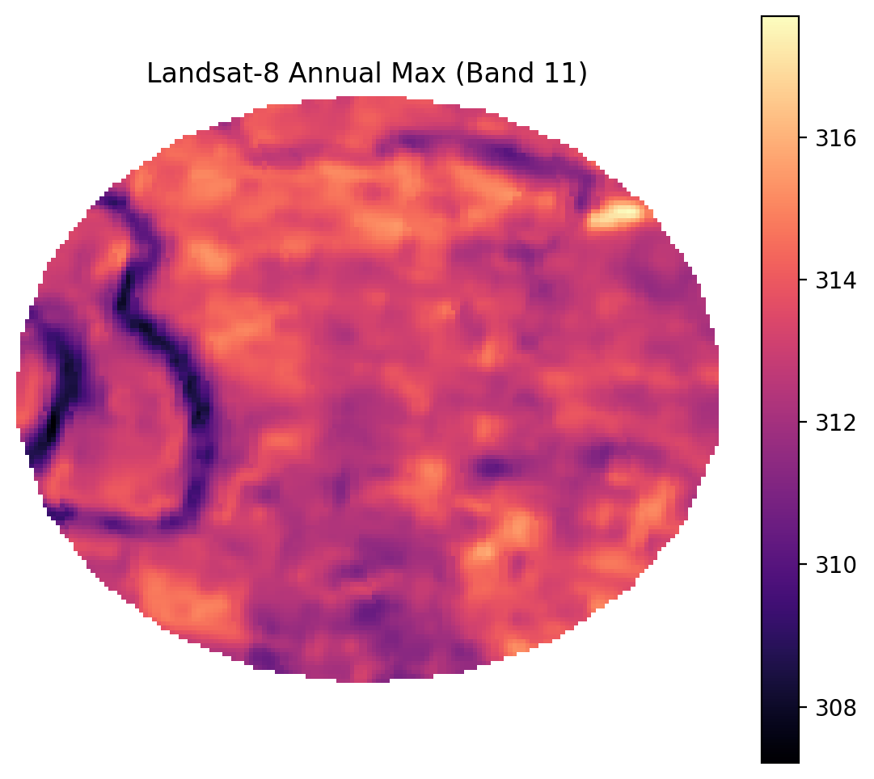

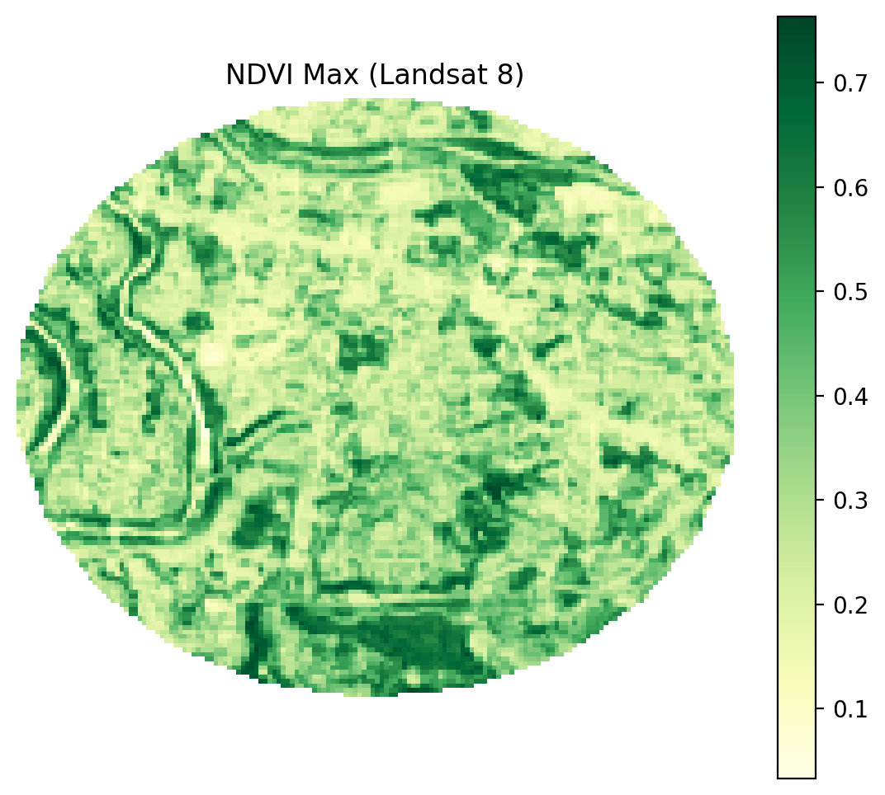

Landsat 8 Bands:
Band Number | Band Name | Wavelength (µm) | Spatial Resolution (m)
1 | Coastal /Aerosol | 0.43–0.45 | 30
2 | Blue | 0.45–0.51 | 30
3 | Green | 0.53–0.59 | 30
4 | Red | 0.64–0.67 | 30
5 | NIR | 0.85–0.88 | 30
6 | SWIR 1 | 1.57–1.65 | 30
7 | SWIR 2 | 2.11–2.29 | 30
8 | PAN (Panchromatic) | 0.50–0.68 | 15
9 | Cirrus | 1.36–1.38 | 30
10 | TIRS 1 (Thermal) | 10.6–11.19 | 100
11 | TIRS 2 (Thermal) | 11.50–12.51 | 100

Complex Urban Settlement Indices:
- Modified Normalized Difference Impervious Surface Index Liu (MNDISI_{Liu})
- Vegetation Temperature Light Index (VTLI)
- Temperature and Vegetation Adjusted NTL Urban Index (TVANUI)
The formulas of these are:

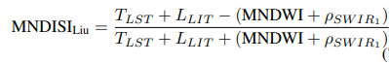
Where:
- T_{LST} : Land Surface Temperature (resampled to optical resolution),
- L_{LIT} : Normalized VIIRS/ISS Nighttime Light Intensity,
- MNDWI: Modified Normalized Difference Water Index,
- ρ_{SWIR1} : SWIR1 reflectance.
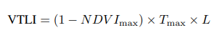
Where:
- NDVI_{max}: annual maximum NDVI from Landsat 8 composites,
- T_{max}: annual maximum monthly daytime Land Surface Temperature (LST),
- L: annual maximum VIIRS NTL

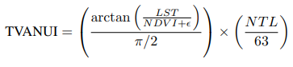
Where:
- LST: Normalized land surface temperature from Landsat 8,
- NDVI: Annual maximum NDVI from Landsat 8, normalized to [0, 1],
- NTL: VIIRS NTL data, normalized to [0, 1],
- ϵ: Small positive constant to prevent division by zero.
The code used for implementation is:
import rasterio
import numpy as np
import matplotlib.pyplot as plt
from matplotlib.colors import ListedColormap
from sklearn.metrics import (
jaccard_score, confusion_matrix, accuracy_score, precision_score,
recall_score, f1_score, balanced_accuracy_score, cohen_kappa_score,
roc_curve, auc
)
from skimage.transform import resize
import pandas as pd
import matplotlib.patches as mpatches
import os

# ======= Settings =======
landsat_path = r'C:\Users\Adeel Ajmal\Downloads\L8_BahriaPhase7_20231012.tif'
landsat_annual_path = r'C:\Users\Adeel Ajmal\Downloads\L8_BahriaPhase7_AnnualMax11Bands_20230101_20250701.tif'
label_path = r'C:\Users\Adeel Ajmal\Downloads\DynamicWorld_LandcoverLabels.tif'
viirs_path = r'C:\Users\Adeel Ajmal\Downloads\VIIRS_NTL_90p_BahriaPhase7_20230101_20250701.tif' # Update if needed
ndvi_max_path = r'C:\Users\Adeel Ajmal\Downloads\L8_NDVImax_BahriaPhase7_20230101_20250701.tif'

outdir = "urban_index_eval_complex_all"
save_figs = True
os.makedirs(outdir, exist_ok=True)

# ======= 1. Load Data =======
with rasterio.open(landsat_path) as src:
stack = src.read().astype('float32')
b1,b2,b3,b4,b5,b6,b7,b8,b9,b10,b11 = stack

with rasterio.open(landsat_annual_path) as src:
stack = src.read().astype('float32')
b1_annual,b2_annual,b3_annual,b4_annual,b5_annual,b6_annual,b7_annual,b8_annual,b9_annual,b10_annual,b11_annual = stack

with rasterio.open(label_path) as src:
labels = src.read(1)

with rasterio.open(viirs_path) as src:
viirs_ntl = src.read(1).astype('float32')

# Load annual max composites

with rasterio.open(ndvi_max_path) as src:
NDVI_max = src.read(1).astype('float32')

gt_mask = (labels == 6).astype(np.uint8)
gt_mask_resized = resize(
gt_mask,
(stack.shape[1], stack.shape[2]),
order=0, preserve_range=True, anti_aliasing=False
).astype(np.uint8)

# ======= 2. Define Indices (as per docx) =======
# Note: Add all requested indices here. All formulas are implemented below.
# For missing bands, formulas are adapted for Landsat 8. Each index is nan-masked if denominator can be zero.
def safe_div(num, denom):
out = np.full_like(num, np.nan)
valid = np.abs(denom) > 1e-6
out[valid] = num[valid] / denom[valid]
return out

indices = {}

# ---------- EXTRA PREP: Reflectance ratio bands (already float32) ----------
# Assumption: stack contains TOA reflectance for optical, TOA BT (Kelvin) for thermal.
rho_red = b4 # reflectance red
rho_nir = b5
rho_swir1= b6
rho_green= b3
rho_swir2= b7
rho_blue = b2

# ---------- 1. NDVI, MNDWI (unchanged) ----------
NDVI = safe_div(rho_nir - rho_red, rho_nir + rho_red)
MNDWI = safe_div(rho_green - rho_swir1, rho_green + rho_swir1)
NDWI = safe_div(rho_green - rho_nir, rho_green + rho_nir)

indices['NDVI'] = NDVI
indices['MNDWI'] = MNDWI

# ======= 4. Normalize VIIRS NTL =======
ntl_mask = np.isfinite(viirs_ntl) & (viirs_ntl > 0)
NTL_min = np.nanmin(viirs_ntl[ntl_mask])
NTL_max = np.nanmax(viirs_ntl[ntl_mask])
NTL_norm = np.zeros_like(viirs_ntl)
NTL_norm[ntl_mask] = (viirs_ntl[ntl_mask] - NTL_min) / (NTL_max - NTL_min)
NTL_norm[~ntl_mask] = 0

# Masked NTL for urban (optional, not used in index formulas, but you can analyze separately)
NTL_urban = NTL_norm * gt_mask_resized

# ======= Implement Urban NTL Indices (add to indices dictionary) =======

# ---- Emissivity (Sun et al. 2019) ----
Pv = ((NDVI - 0.2) / 0.3)**2
ε = np.where(
NDVI < 0.2,
0.979 - 0.035 * rho_red,
np.where(
NDVI <= 0.5,
0.986 + 0.004 * Pv,
0.990
)
)
ε = np.clip(ε, 0.85, 0.999) # keep within physical bounds

# ---- LST (Kelvin, Sun et al. Eq. 56) ----
λ = 10.8e-6 # central wavelength (m) for L8 band 10
ρ_const = 1.438e-2 # m·K
Tb = b10 # Band 10: TOA Brightness Temp in Kelvin
LST = Tb / (1 + (λ * Tb / ρ_const) * np.log(ε))
LST_norm = (LST - np.nanmin(LST)) / (np.nanmax(LST) - np.nanmin(LST) + 1e-6)

# --- MNDSI_Liu ---
rho_swir1_norm = (rho_swir1 - np.nanmin(rho_swir1)) / (np.nanmax(rho_swir1) - np.nanmin(rho_swir1) + 1e-6)
num = LST + NTL_norm - (MNDWI + rho_swir1_norm)
den = LST + NTL_norm + MNDWI + rho_swir1_norm + 1e-6
MNDSI_Liu = num / den
indices['MNDSI_Liu'] = MNDSI_Liu

# --- VTLI ---

Pv = ((NDVI_max - 0.2) / 0.3)**2
ε = np.where(
NDVI_max < 0.2,
0.979 - 0.035 * b4_annual,
np.where(
NDVI_max <= 0.5,
0.986 + 0.004 * Pv,
0.990
)
)
ε = np.clip(ε, 0.85, 0.999) # keep within physical bounds

# ---- LST (Kelvin, Sun et al. Eq. 56) ----
λ = 10.8e-6 # central wavelength (m) for L8 band 10
ρ_const = 1.438e-2 # m·K
Tb = b10_annual # Band 10: TOA Brightness Temp in Kelvin
LST_max = Tb / (1 + (λ * Tb / ρ_const) * np.log(ε))

VTLI = (1 - NDVI_max) * LST_max * NTL_norm
indices['VTLI'] = VTLI

# --- TVANUI ---
epsilon = 1e-6
LST_div = LST_norm / (NDVI_max + epsilon)
arctan_part = np.arctan(LST_div) / (np.pi / 2)
NTL_063 = NTL_norm
TVANUI = arctan_part * NTL_063
indices['TVANUI'] = TVANUI

# --- LST itself (optional visualization) ---
indices['LST'] = LST
indices['LST_max'] = LST_max
# ======= 7. NDVI Threshold Search & Best Mask =======
ndvi_thresholds = np.arange(0.1, 0.81, 0.05)
best_results = {}
all_results = {}

def best_threshold(idx, truth, n_steps=200):
v = np.isfinite(idx) & np.isfinite(truth)
x, y = idx[v].ravel(), truth[v].ravel()
best_thr, best_iou = None, -1
for thr in np.linspace(np.nanmin(x), np.nanmax(x), n_steps):
y_pred = (x > thr).astype(np.uint8)
if y_pred.sum() == 0: continue
iou = jaccard_score(y, y_pred, zero_division=0)
if iou > best_iou: best_thr, best_iou = thr, iou
return best_thr

def metrics(mask_pred, truth, idx_pred_scores=None):
v = np.isfinite(mask_pred) & np.isfinite(truth)
y_pred, y_true = mask_pred[v].ravel(), truth[v].ravel()
out = dict(
IoU=jaccard_score(y_true, y_pred, zero_division=0),
F1=f1_score(y_true, y_pred, zero_division=0),
Pr=precision_score(y_true, y_pred, zero_division=0),
Re=recall_score(y_true, y_pred, zero_division=0),
Acc=accuracy_score(y_true, y_pred),
BAc=balanced_accuracy_score(y_true, y_pred),
Kappa=cohen_kappa_score(y_true, y_pred)
)
tn, fp, fn, tp = confusion_matrix(y_true, y_pred, labels=[0,1]).ravel()
out.update({"TP":tp,"TN":tn,"FP":fp,"FN":fn})
if idx_pred_scores is not None:
v2 = v & np.isfinite(idx_pred_scores)
y_true2 = truth[v2].ravel()
y_score2 = idx_pred_scores[v2].ravel()
if len(np.unique(y_true2)) > 1 and len(y_score2) > 0:
try:
fpr, tpr, _ = roc_curve(y_true2, y_score2)
out["AUC"] = auc(fpr, tpr)
except Exception as e:
out["AUC"] = np.nan
else:
out["AUC"] = np.nan
else:
out["AUC"] = np.nan
return out

for idx_name, idx in indices.items():
metric_by_thr = []
for ndvi_thr in ndvi_thresholds:
thr = best_threshold(idx, gt_mask_resized)
pred = ((idx > thr) & (NDVI < ndvi_thr)).astype(np.uint8)
result = metrics(pred, gt_mask_resized, idx_pred_scores=idx)
result['ndvi_thr'] = ndvi_thr
result['idx_thr'] = thr
metric_by_thr.append(result)
df_thr = pd.DataFrame(metric_by_thr)
best_i = df_thr['IoU'].idxmax()
best_results[idx_name] = df_thr.loc[best_i].to_dict()
all_results[idx_name] = df_thr

# ======= 8. Visualization: 3-panel for Each Index =======
class_palette = [
"#419bdf", "#397d49", "#88b053", "#7a87c6", "#e49635",
"#dfc35a", "#c4281b", "#a59b8f", "#ffffff"
]
class_names = [
"Water", "Trees", "Grass", "Flooded Veg", "Crops",
"Shrub/Scrub", "Built", "Bare", "Snow/Ice"
]
label_viz = resize(labels, (stack.shape[1], stack.shape[2]), order=0, preserve_range=True, anti_aliasing=False)

rgb = np.stack([b4, b3, b2], -1)
p2, p98 = np.nanpercentile(rgb, (2, 98))
rgb = np.clip((rgb - p2) / (p98 - p2), 0, 1)
rgb[np.isnan(rgb)] = 0

URBAN_COLOR = np.array([1.0, 0.1, 0.1])
NON_URBAN_COLOR = np.array([0.65, 0.65, 0.65])

for idx_name, idx in indices.items():
best = best_results[idx_name]
ndvi_thr = best['ndvi_thr']
idx_thr = best['idx_thr']
pred = ((idx > idx_thr) & (NDVI < ndvi_thr)).astype(np.uint8)

fig, axs = plt.subplots(1, 3, figsize=(22, 7))
axs[0].imshow(rgb)
axs[0].set_title("Landsat-8 RGB")
axs[0].axis('off')

im2 = axs[1].imshow(label_viz, cmap=ListedColormap(class_palette), vmin=0, vmax=8)
axs[1].set_title("Dynamic World Labels")
axs[1].axis('off')
cbar = plt.colorbar(im2, ax=axs[1], ticks=np.arange(0,9), shrink=0.8)
cbar.ax.set_yticklabels(class_names)

idx_disp = np.copy(idx)
idx_disp[~np.isfinite(idx_disp)] = np.nan
axs[2].imshow(idx_disp, cmap='RdYlBu')
gt_viz = np.zeros((*gt_mask_resized.shape, 3), dtype=np.float32)
gt_viz[gt_mask_resized == 1] = URBAN_COLOR
gt_viz[gt_mask_resized == 0] = NON_URBAN_COLOR
pred_viz = np.zeros((*pred.shape, 3), dtype=np.float32)
pred_viz[pred == 1] = URBAN_COLOR
pred_viz[pred == 0] = NON_URBAN_COLOR
axs[2].imshow(0.6*gt_viz + 0.4*pred_viz, alpha=0.45)
axs[2].set_title(f"{idx_name} Index\nIoU={best['IoU']:.3f} NDVI<{ndvi_thr:.2f}")
axs[2].axis('off')
handles = [
mpatches.Patch(color=URBAN_COLOR, label='Urban'),
mpatches.Patch(color=NON_URBAN_COLOR, label='Non-Urban')
]
axs[2].legend(handles=handles, loc='lower right', fontsize=12)
plt.tight_layout()
if save_figs:
plt.savefig(os.path.join(outdir, f"{idx_name}_urban3panel.png"), dpi=200, bbox_inches='tight')
plt.show()

# ======= 9. Save Summary Table =======
header = "{:<10} {:>8} {:>8} {:>8} {:>8} {:>8} {:>8} {:>8} {:>8} {:>6} {:>8}".format(
"Index","IoU","F1","Pr","Re","Acc","BAc","Kappa","AUC","TP","NDVI_thr")
print(header)
print("-"*len(header))
for k,v in best_results.items():
print("{:<10} {:8.3f} {:8.3f} {:8.3f} {:8.3f} {:8.3f} {:8.3f} {:8.3f} {:8.3f} {:6.0f} {:8.2f}".format(
k, v['IoU'], v['F1'], v['Pr'], v['Re'], v['Acc'], v['BAc'], v['Kappa'], v['AUC'], v['TP'], v['ndvi_thr']))
df = pd.DataFrame(best_results).T
df.to_csv(os.path.join(outdir, "urban_index_metrics_best.csv"))
for k, df_thr in all_results.items():
df_thr.to_csv(os.path.join(outdir, f"{k}_ndvi_threshold_sweep.csv"))
print("GT Urban Fraction: {:.2%}".format(gt_mask_resized.mean()))
vals, counts = np.unique(label_viz.astype(int), return_counts=True)
total = label_viz.size
print("\n--- Land Cover Breakdown (Dynamic World) ---")
for v, c in zip(vals, counts):
print(f"{class_names[v]:<12}: {c/total*100:5.2f}%")

import numpy as np
import matplotlib.pyplot as plt
from sklearn.metrics import confusion_matrix
import seaborn as sns
import os

def plot_confusion_matrix(y_true, y_pred, idx_name, outdir, labels=['Non-Urban', 'Urban']):
cm = confusion_matrix(y_true, y_pred, labels=[0,1])
plt.figure(figsize=(4,4))
sns.heatmap(cm, annot=True, fmt='d', cmap='Blues',
xticklabels=labels, yticklabels=labels,
cbar=False)
plt.xlabel('Predicted Label')
plt.ylabel('True Label')
plt.title(f'{idx_name} - Confusion Matrix')
plt.tight_layout()
# Save the figure
plt.savefig(os.path.join(outdir, f"{idx_name}_confusion_matrix.png"), dpi=150)
plt.close()

# Main loop: Go through all indices
for idx_name, idx in indices.items():
best = best_results[idx_name]
ndvi_thr = best['ndvi_thr']
idx_thr = best['idx_thr']
pred = ((idx > idx_thr) & (NDVI < ndvi_thr)).astype(np.uint8)
y_true = gt_mask_resized.ravel()
y_pred = pred.ravel()
plot_confusion_matrix(y_true, y_pred, idx_name, outdir)

print(f"Confusion matrix PNGs saved to {outdir}")

Output:
MNDSI_{LIU} Result:
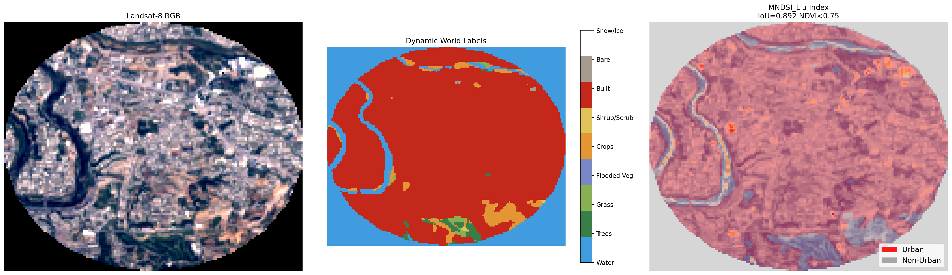

VTLI Result:
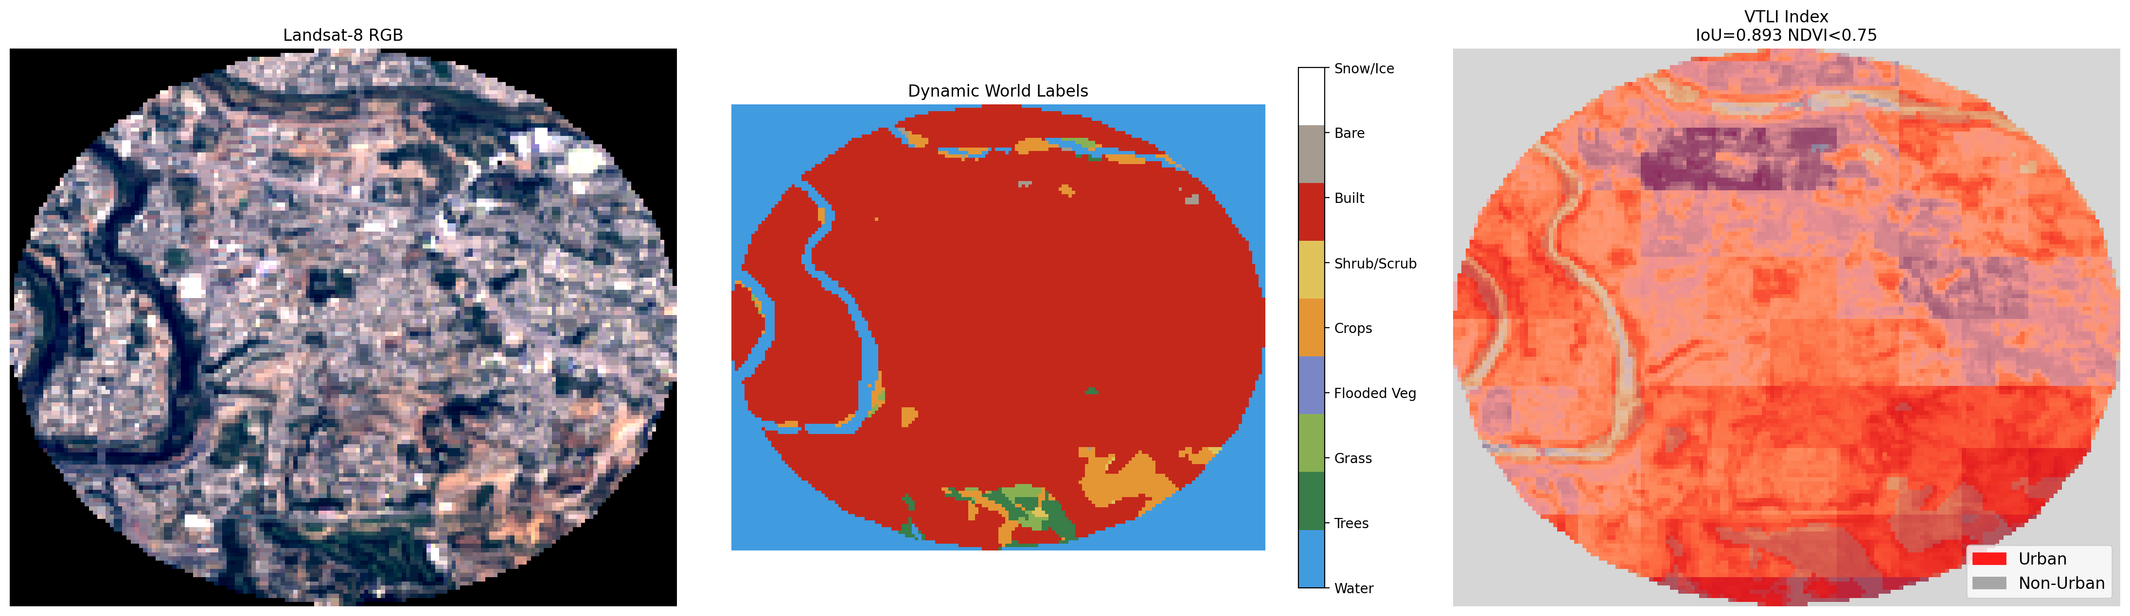
TVANUI Result:
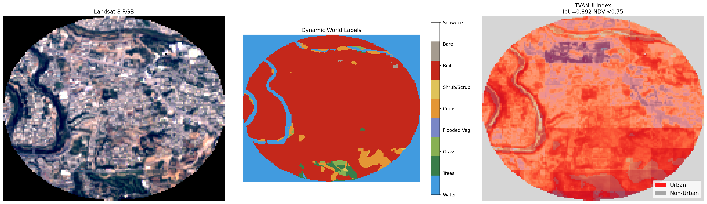

Metrics Result For Each Index:
Index Name | IoU-score | F1-score | Precision | Recall | Accuracy | Balanced Accuracy Score | Kappa Score
MNDSI_{LIU} | 0.891773 | 0.942791 | 0.892885 | 0.998606 | 0.914832 | 0.85769 | 0.778233
VTLI | 0.893337 | 0.943664 | 0.899627 | 0.992235 | 0.916744 | 0.865253 | 0.785672
TVANUI | 0.892476 | 0.943184 | 0.897018 | 0.994359 | 0.915812 | 0.862235 | 0.78238

Index Name | True Positives | True Negatives | False Positives | False Negatives | Area Under the Curve | NDVI threshold
MNDSI_{LIU} | 15046 | 4568 | 1805 | 21 | 0.34584 | 0.75
VTLI | 14950 | 4705 | 1668 | 117 | 0.729164 | 0.75
TVANUI | 14982 | 4653 | 1720 | 85 | 0.781851 | 0.75

Confusion Matrices of Indices:
